


SAVEETHA SCHOOL OF ENGINEERING

SAVEETHA INSTITUTE OF MEDICAL AND TECHNICAL SCIENCES

COMPUTER SCIENCE AND ENGINEERING PROGRAMME

LAB MANUAL CSA1305

THEORY OF COMPUTATION

COMPUTER SCIENCE AND ENGINEERING PROGRAMME

LIST OF EXPERIMENTS

- To write a C program to check whether a string belongs to the grammar S -> 0 S 0 | 1 S 1 | 0 | 1 | ε
AIM:
To write a C program to check whether a string belongs to the grammar:
S → 0 S 0 | 1 S 1 | 0 | 1 | ε

Apparatus Required
- Computer/Laptop
- GCC Compiler (Turbo C/GCC/CodeBlocks/VS Code)
- C Programming Language

Algorithm
- Start the program.
- Read the input string.
- Compare the characters from the beginning and end of the string.
- If all corresponding characters are equal, the string is a palindrome.
- Otherwise, the string does not belong to the grammar.
- Display the result.
- Stop the program.

Program Code

#include <stdio.h>

#include <string.h>

int main()

{

char str[100];

int i, len, flag = 1;

printf("Enter the string: ");

scanf("%s", str);

len = strlen(str);

for(i = 0; i < len / 2; i++)

{

if(str[i] != str[len - i - 1])

{

flag = 0;

break;

}

}

if(flag)

printf("The string belongs to the grammar.\n");

else

printf("The string does not belong to the grammar.\n");

return 0;

}

Sample Input 1
Enter the string: 01110

Sample Output 1
The string belongs to the grammar.

OUTPUT: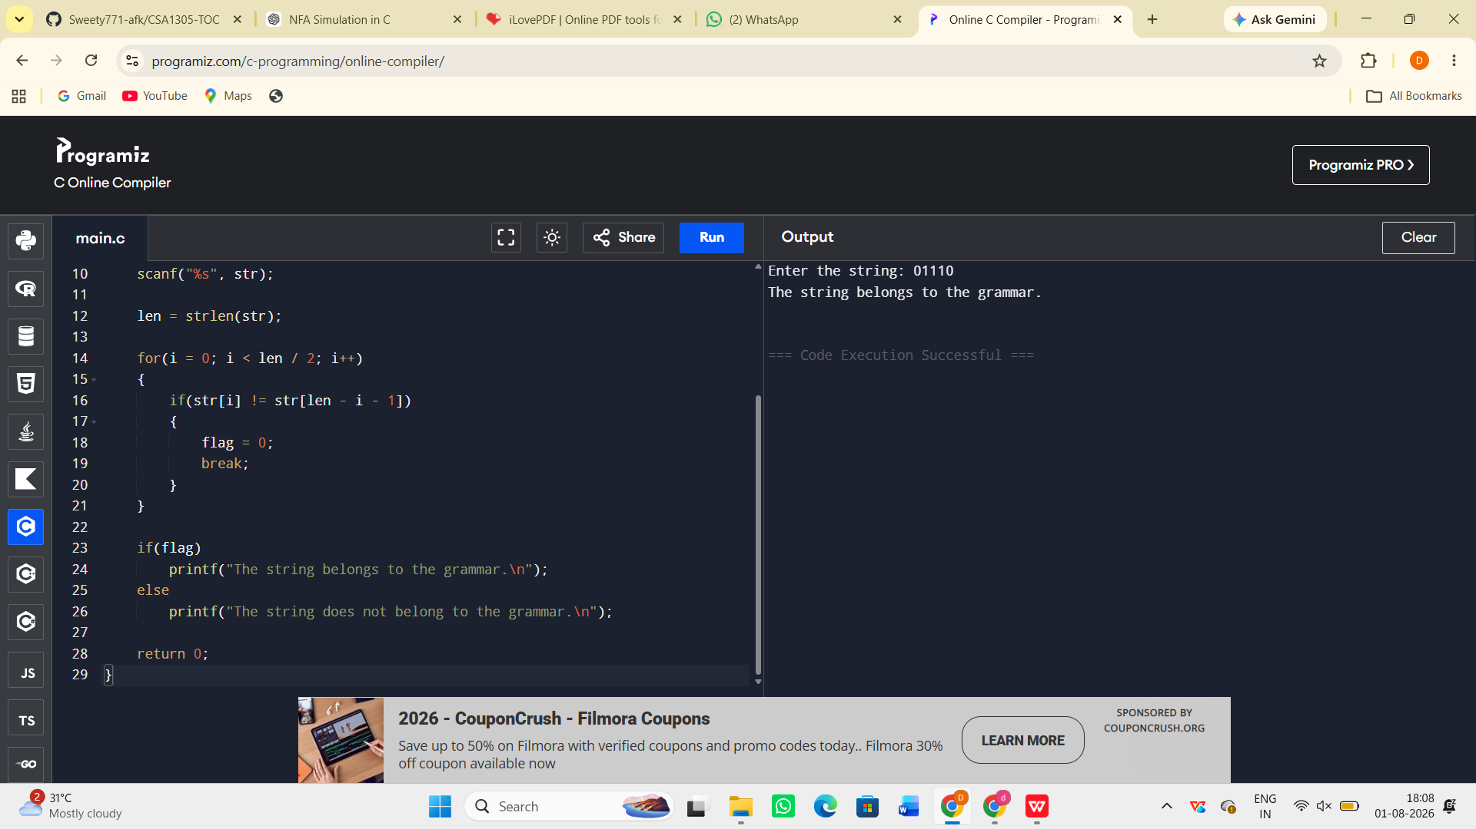

Result:
The C program to check whether a given string belongs to the grammar S → 0 A 1, A → 0 A | 1 A | ε was successfully implemented and executed. The program correctly accepts strings that start with 0 and end with 1 and rejects all other strings.

